Lab 6 –Stored Procedures/Conditional Statements)

## Submission

***Your submission will be a single Word file. Question followed by procedure and output***

In this Lab, you create PL/SQL stored procedures to perform the following tasks. As you know, a stored procedure does not return any value. To send values back to the caller, you can use OUT parameters.

A parameter can be

* IN parameter
* OUT parameter
* IN OUT parameter

See the following template:

|  |
| --- |
| **CREATE** **OR REPLACE** *procedure_name*(**arg1** **IN**/**OUT/IN OUT** data_type, ...) AS  **BEGIN**  ....  **EXCEPTION**  **WHEN OTHERS**  **THEN**  DBMS_OUTPUT.PUT_LINE (Error!');  **END** procedure_name; |

**For all the stored procedures make sure you handle all exceptions such as**

* TOO_MANY_ROWS
* NO_DATA_FOUND
* OTHERS
* . . .

Besides checking all required exceptions, have the OTHER exception checked just in case any error occurs that has not been anticipated at the time you write the code.

## Tasks

NOTE: Remember SET SERVEROUTPUT ON or you will not see anything working. Place it the beginning.

1. Create a PL/SQL procedure to check if the office code 8 exists in Retail Offices table. Display a message if it exists and display a message if it doesn’t exist with the office code supplied. Try for office code 1 and display the result.

**SET SERVEROUTPUT ON;**

**CREATE OR REPLACE PROCEDURE check_office_exists(p_office_code NUMBER) AS**

**v_count NUMBER;**

**BEGIN**

**SELECT COUNT(*) INTO v_count**

**FROM RetailOffices**

**WHERE OfficeCode = p_office_code;**

**IF v_count > 0 THEN**

**DBMS_OUTPUT.PUT_LINE('Office code ' || p_office_code || ' exists.');**

**ELSE**

**DBMS_OUTPUT.PUT_LINE('Office code ' || p_office_code || ' does not exist.');**

**END IF;**

**EXCEPTION**

**WHEN OTHERS THEN**

**DBMS_OUTPUT.PUT_LINE('Error!');**

**END check_office_exists;**

**BEGIN**

**check_office_exists(1);**

**END;**

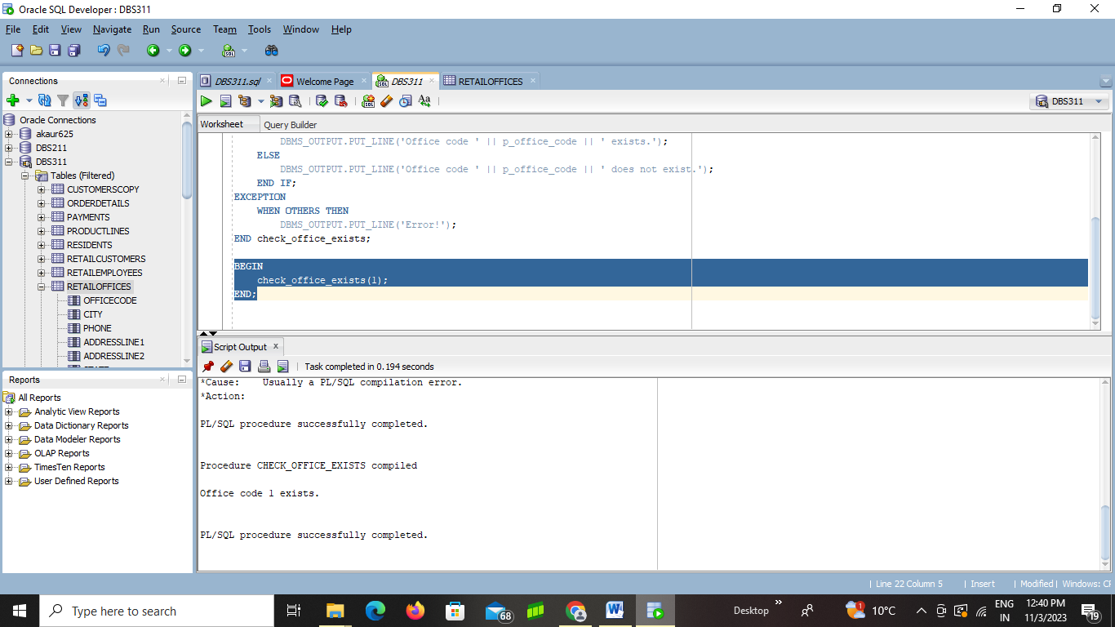

-------------------------------------------------------------------------------------------------------------------------------------------------

1. Create a PL/SQL procedure to display all the required field details from Retail Offices table for the office code 1. Display a message if the Office Code doesn’t exist and display all the required fields of Retail Office if the office code exist. Try for office code 8 and display the result.

**SET SERVEROUTPUT ON;**

**CREATE OR REPLACE PROCEDURE DisplayRetailOfficeDetails(p_office_code NUMBER) IS**

**v_office_code retailoffices.officecode%TYPE;**

**v_city retailoffices.city%TYPE;**

**v_phone retailoffices.phone%TYPE;**

**v_addressline1 retailoffices.addressline1%TYPE;**

**v_addressline2 retailoffices.addressline2%TYPE;**

**v_state retailoffices.state%TYPE;**

**v_country retailoffices.country%TYPE;**

**v_postalcode retailoffices.postalcode%TYPE;**

**v_territory retailoffices.territory%TYPE;**

**BEGIN**

**SELECT officecode, city, phone, addressline1, addressline2, state, country, postalcode, territory**

**INTO v_office_code, v_city, v_phone, v_addressline1, v_addressline2, v_state, v_country, v_postalcode, v_territory**

**FROM retailoffices**

**WHERE officecode = p_office_code;**

**DBMS_OUTPUT.PUT_LINE('Office Code: ' || v_office_code);**

**DBMS_OUTPUT.PUT_LINE('City: ' || v_city);**

**DBMS_OUTPUT.PUT_LINE('Phone: ' || v_phone);**

**DBMS_OUTPUT.PUT_LINE('Address Line 1: ' || v_addressline1);**

**DBMS_OUTPUT.PUT_LINE('Address Line 2: ' || v_addressline2);**

**DBMS_OUTPUT.PUT_LINE('State: ' || v_state);**

**DBMS_OUTPUT.PUT_LINE('Country: ' || v_country);**

**DBMS_OUTPUT.PUT_LINE('Postal Code: ' || v_postalcode);**

**DBMS_OUTPUT.PUT_LINE('Territory: ' || v_territory);**

**EXCEPTION**

**WHEN NO_DATA_FOUND THEN**

**DBMS_OUTPUT.PUT_LINE('Office Code ' || p_office_code || ' doesn’t exist.');**

**END;**

**/**

**-- To display details for office code 1**

**EXEC DisplayRetailOfficeDetails(1);**

**-- To display details for office code 8**

**EXEC DisplayRetailOfficeDetails(8);**



-------------------------------------------------------------------------------------------------------------------------------------------------

1. Create a PL/SQL procedure to INSERT a new office as given below into Retail Offices table. Display a message if the new office was added and display all the added fields of Retail Office once the INSERT is complete.

Information to add: Office code as 15, city as Vancouver, address as 100 Island St, Country as Canada, postal code as a1w333, province as BC, phone number as +1 215 837 0825.

**SET SERVEROUTPUT ON;**

**CREATE OR REPLACE PROCEDURE insert_new_office AS**

**BEGIN**

**INSERT INTO RetailOffices (**

**officecode,**

**city,**

**phone,**

**addressline1,**

**addressline2,**

**state,**

**country,**

**postalcode,**

**territory**

**)**

**VALUES (**

**15,**

**'Vancouver',**

**'+1 215 837 0825',**

**'100 Island St',**

**NULL, -- Assuming addressline2 is optional**

**'BC',**

**'Canada',**

**'a1w333',**

**'YourTerritory' -- Provide an actual value for territory**

**);**

**DBMS_OUTPUT.PUT_LINE('New office added successfully.');**

**EXCEPTION**

**WHEN OTHERS THEN**

**DBMS_OUTPUT.PUT_LINE('Error adding new office: ' || SQLERRM);**

**END insert_new_office;**

**BEGIN**

**insert_new_office;**

**END;**

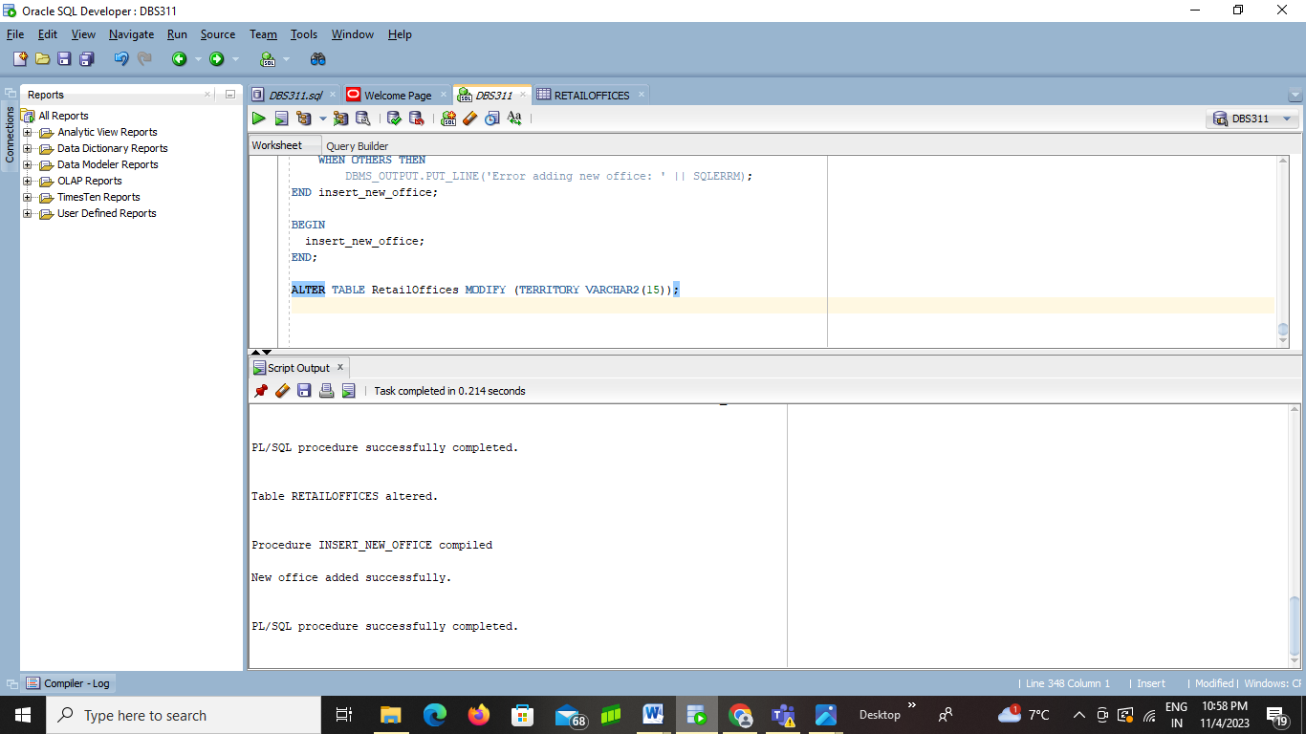

-------------------------------------------------------------------------------------------------------------------------------------------------

1. Create a PL/SQL procedure to UPDATE the new postal code as ‘M1HV1H’ for the office code 15 in the Retail Offices table. Display a message if the postal code was updated and display the updated fields of Retail Office once the UPDATE is complete.

**CREATE OR REPLACE PROCEDURE UpdateRetailOfficePostalCode IS**

**BEGIN**

**UPDATE retailoffices**

**SET postalcode = 'M1HV1H'**

**WHERE officecode = 15;**

**IF SQL%ROWCOUNT > 0 THEN**

**DBMS_OUTPUT.PUT_LINE('Postal code for Office Code 15 has been updated.');**

**-- Display the updated fields for the office**

**DBMS_OUTPUT.PUT_LINE('Office Code: 15');**

**DBMS_OUTPUT.PUT_LINE('Postal Code: M1HV1H');**

**COMMIT; -- Commit the transaction**

**ELSE**

**DBMS_OUTPUT.PUT_LINE('No office with Office Code 15 found for updating.');**

**END IF;**

**EXCEPTION**

**WHEN OTHERS THEN**

**DBMS_OUTPUT.PUT_LINE('Error: Unable to update the postal code.');**

**ROLLBACK; -- Rollback the transaction in case of an error**

**END;**

**/**

**EXEC UpdateRetailOfficePostalCode;**

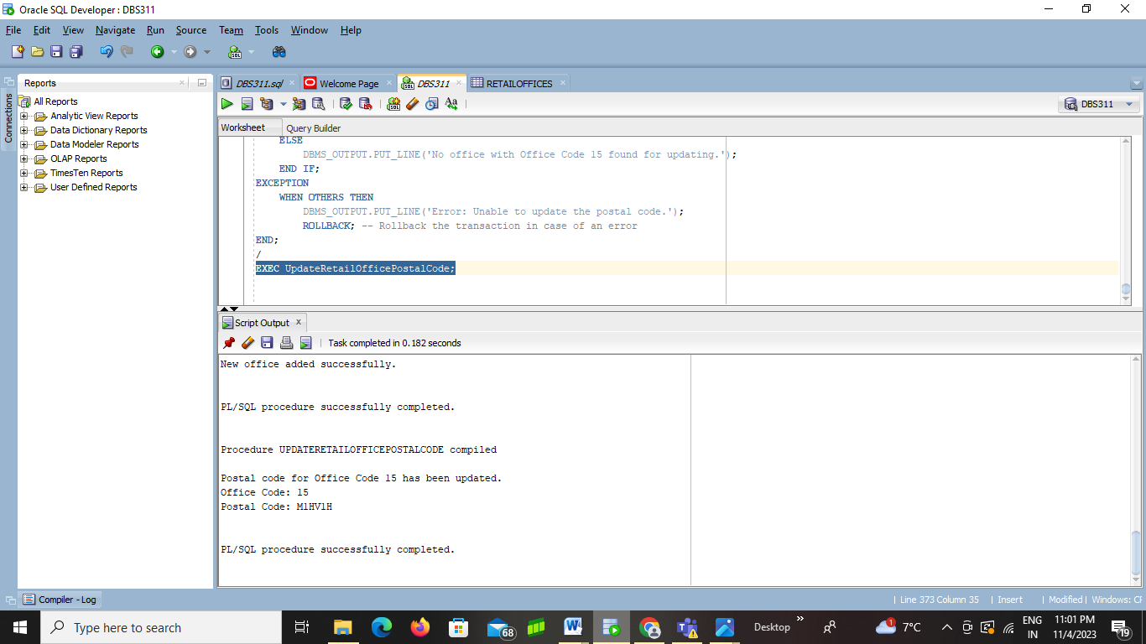

-------------------------------------------------------------------------------------------------------------------------------------------------

1. Create a PL/SQL procedure to DELETE the office code 15 in the Retail Offices table. Display a message if the postal code was deleted.

**SET SERVEROUTPUT ON;**

**CREATE OR REPLACE PROCEDURE DeleteRetailOffice IS**

**BEGIN**

**DELETE FROM retailoffices**

**WHERE officecode = 15;**

**IF SQL%ROWCOUNT > 0 THEN**

**DBMS_OUTPUT.PUT_LINE('Office with Office Code 15 has been deleted.');**

**COMMIT; -- Commit the transaction**

**ELSE**

**DBMS_OUTPUT.PUT_LINE('No office with Office Code 15 found for deletion.');**

**END IF;**

**EXCEPTION**

**WHEN OTHERS THEN**

**DBMS_OUTPUT.PUT_LINE('Error: Unable to delete the office.');**

**ROLLBACK; -- Rollback the transaction in case of an error**

**END;**

**/**

**EXEC DeleteRetailOffice;**

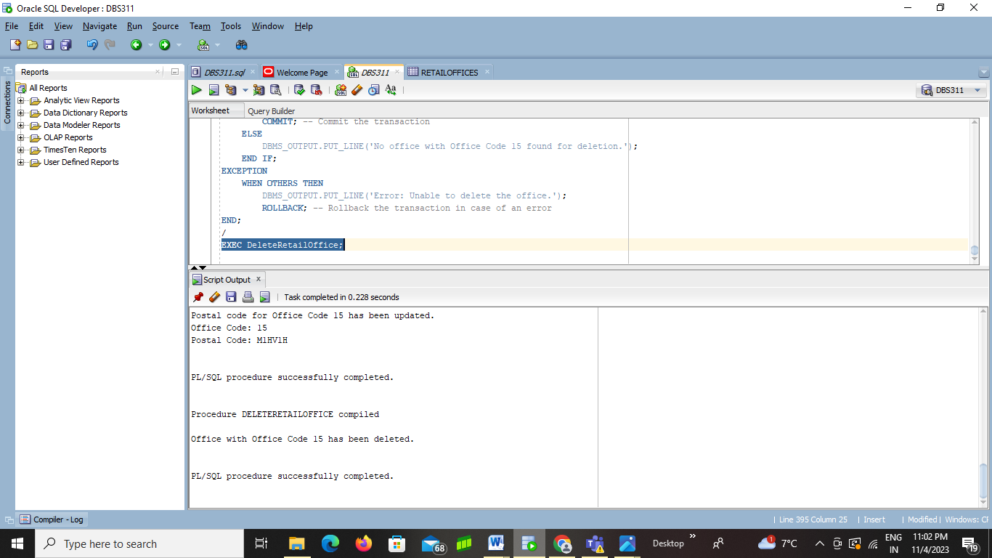

-----------------------------------------------------------------------------------------------------------------------------------------------

1. Write a stored procedure that gets an integer number and prints

*The number is divisible by 100.*

If a number is divisible by 100.

Otherwise, it prints

*The number is not divisible by 100.*

**SET SERVEROUTPUT ON;**

**CREATE OR REPLACE PROCEDURE CheckDivisibilityBy100(p_number IN NUMBER) IS**

**BEGIN**

**IF MOD(p_number, 100) = 0 THEN**

**DBMS_OUTPUT.PUT_LINE('The number ' || p_number || ' is divisible by 100.');**

**ELSE**

**DBMS_OUTPUT.PUT_LINE('The number ' || p_number || ' is not divisible by 100.');**

**END IF;**

**END;**

**/**

**-- Check if 500 is divisible by 100**

**EXEC CheckDivisibilityBy100(500);**

**-- Check if 1200 is divisible by 100**

**EXEC CheckDivisibilityBy100(1200);**



-------------------------------------------------------------------------------------------------------------------------------------------------

1. Create a stored procedure named *find_Order*. This procedure gets an order number and prints the following retail order information:

Order Number

Order Date

Status

CustomerNumber

The procedure gets a value as the order number of type NUMBER.

See the following sample output for order number 10422:

Order Number :10422

Order Date : 31-MAY-05

Status :In Progress

CustomerNumber :103

The procedure displays a proper error message if any error occurs like ordernumber doesn’t exist or invalid.

**SET SERVEROUTPUT ON;**

**CREATE OR REPLACE PROCEDURE find_Order(p_order_number IN NUMBER) IS**

**v_order_number NUMBER;**

**v_order_date DATE;**

**v_status VARCHAR2(50);**

**v_customer_number NUMBER;**

**BEGIN**

**-- Retrieve the order information based on the provided order number**

**SELECT ordernumber, orderdate, status, customernumber**

**INTO v_order_number, v_order_date, v_status, v_customer_number**

**FROM retailorders**

**WHERE ordernumber = p_order_number;**

**-- Display the order information**

**DBMS_OUTPUT.PUT_LINE('Order Number: ' || v_order_number);**

**DBMS_OUTPUT.PUT_LINE('Order Date: ' || TO_CHAR(v_order_date, 'DD-MON-YY'));**

**DBMS_OUTPUT.PUT_LINE('Status: ' || v_status);**

**DBMS_OUTPUT.PUT_LINE('Customer Number: ' || v_customer_number);**

**EXCEPTION**

**WHEN NO_DATA_FOUND THEN**

**DBMS_OUTPUT.PUT_LINE('Error: Order Number ' || p_order_number || ' doesn’t exist.');**

**WHEN OTHERS THEN**

**DBMS_OUTPUT.PUT_LINE('Error: Invalid order number or database error occurred.');**

**END;**

**/**

**-- Retrieve information for Order Number 10422**

**EXEC find_Order(10422);**



-------------------------------------------------------------------------------------------------------------------------------------------------

1. Create a newProduct table from retailproducts with all the data. Every year, the retail company increases the price of all retail products in one product line. For example, the company wants to increase the buying price of retail products of product line ‘Train’ by $500.

Write a procedure named *update_price_productline* to update the buying price of all products in the given product line and the given amount to be added to the current buying price if the price is greater than 30.

The procedure shows the number of updated rows if the update is successful.

The procedure gets two parameters:

* Prod_type IN VARCHAR2
* amount NUMBER(9,2)

To define the type of variables that store values of a table column, you can also write:

variable_name table_name.column_name%type;

The above statement defines a variable of the same type as the type of the table column.

Example: productline newProduct.productline%type;

Or you need to see the table definition to find the type of the buying price update column. Make sure the type of your variable is compatible with the value that is stored in your variable.

To show the number of affected rows the update query, declare a variable named rows_updated of type NUMBER and use the SQL variable sql%rowcount to set your variable. Then, print its value in your stored procedure. (Something like this is in the notes supplied to you)

Rows_updated := sql%rowcount;

SQL%*ROWCOUNT* stores the number of rows affected by an INSERT, UPDATE, or DELETE.

**SET SERVEROUTPUT ON;**

**CREATE OR REPLACE PROCEDURE update_price_productline(**

**Prod_type IN retailproducts.productline%TYPE,**

**quantityinstock NUMBER**

**) AS**

**rows_updated NUMBER;**

**BEGIN**

**UPDATE retailproducts**

**SET buyprice = buyprice + quantityinstock**

**WHERE productline = Prod_type**

**AND buyprice > 30;**

**rows_updated := SQL%ROWCOUNT;**

**DBMS_OUTPUT.PUT_LINE('Number of updated rows: ' || rows_updated);**

**EXCEPTION**

**WHEN OTHERS THEN**

**DBMS_OUTPUT.PUT_LINE('Error updating prices: ' || SQLERRM);**

**END update_price_productline;**

**BEGIN**

**update_price_productline('Train', 500);**

**END;**

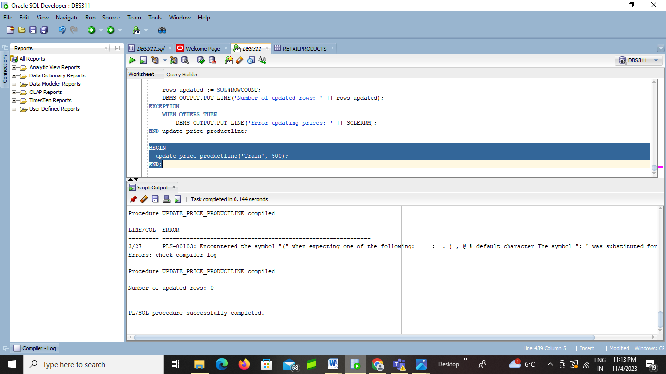

--------------------------------------------------------------------------------------------------------------------------------------------------

1. Create newOrderDetails table from orderdetails. Every year, the company increases the price of each product by 1 or 2% (Example of 2% -- priceeach * 1.02) based on if the selling price (priceeach) is less than the average price of all order details table.

Write a stored procedure named *update_low_prices_123456789 where 123456789 is replaced by your student number.*

This procedure does not have any parameters. You need to find the average sell price (priceeach) of all products and store it into a variable of the same data type. If the average price is less than or equal to $1000, then update the products selling price(priceeach) by 2% if that products sell price is less than the calculated average.

If the average price is greater than $1000, then update products selling price (priceeach) by 1% if the price of the products selling price is less than the calculated average.

The query displays an error message if any error occurs. Otherwise, it displays the number of updated rows.

An example of an output produced by your code might be the following or perhaps nicer

**\*\*\* OUTPUT update_low_prices_123456789 STARTED \*\*\***

**Number of updates: 27**

**----ENDED --------**

CREATE OR REPLACE PROCEDURE update_low_prices_123456789 IS

avg_price NUMBER(10,2);

BEGIN

**-- Calculate the average selling price**

**SELECT AVG(priceeach) INTO avg_price FROM orderdetails;**

**-- Check if the average price is less than or equal to $1000**

**IF avg_price <= 1000 THEN**

**-- Update products with 2% increase if priceeach < avg_price**

**UPDATE orderdetails**

**SET priceeach = priceeach * 1.02**

**WHERE priceeach < avg_price;**

**ELSE**

**-- Update products with 1% increase if priceeach < avg_price**

**UPDATE orderdetails**

**SET priceeach = priceeach * 1.01**

**WHERE priceeach < avg_price;**

**END IF;**

**-- Display the number of updated rows**

**DBMS_OUTPUT.PUT_LINE('Number of updates: ' || SQL%ROWCOUNT);**

**EXCEPTION**

**WHEN OTHERS THEN**

**DBMS_OUTPUT.PUT_LINE('Error: ' || SQLERRM);**

**END;**

**/**

**BEGIN**

**update_low_prices_123456789;**

**END;**

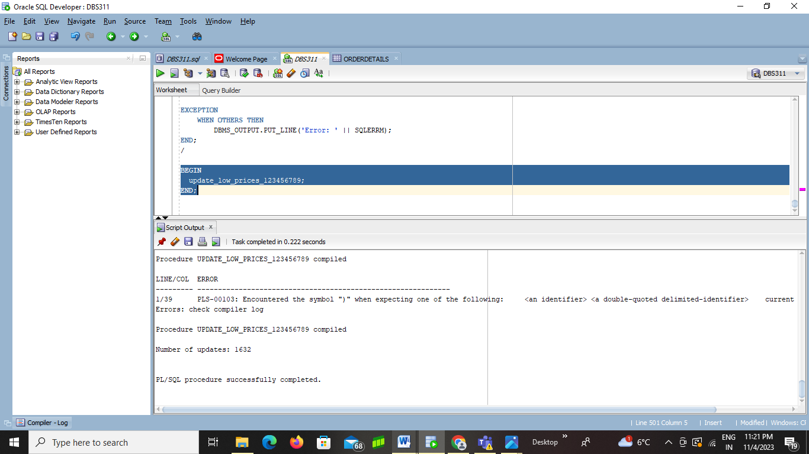

--------------------------------------------------------------------------------------------------------------------------------------------------

1. Create a tempPayment table from retailpayments. The company needs a report that shows three categories of payment based on their amount. The company needs to know if the payment amount is cheap, fair, or expensive. Let us assume that

- If the amount is less than the (average amount – minimum amount) divided by 2

The product’s payment is LOW.

- If the amount is greater than the maximum less the average divided by 2

The product’ payment is HIGH.

- If the amount is between

* + (average amount – minimum amount) / 2 AND (maximum amount – average amount) / 2 INCLUSIVE

The product’s payment is fair.

Write a procedure named *payment_report_123456789 where 123456789 is replaced by your student number.*

to show the number of payments in each payment category:

The following is a sample output of the procedure if no error occurs:

Low: 10

Fair: 50

High: 18

The values in the above examples are just random values and may not match the real numbers in your result.

The procedure has no parameter. First, you need to find the average, minimum, and maximum prices (amount) in your database and store them into variables avg_amt, min_amt, and max_amt.

You need three more variables to store the number of payments in each price category:

low_count  
fair_count  
high_count

Make sure you choose a proper type for each variable. You may need to define more variables based on your solution.

**CREATE OR REPLACE PROCEDURE payment_report_123456789 IS**

**avg_amt NUMBER(10,2);**

**min_amt NUMBER(10,2);**

**max_amt NUMBER(10,2);**

**low_count INT := 0;**

**fair_count INT := 0;**

**high_count INT := 0;**

**BEGIN**

**-- Calculate average, minimum, and maximum prices**

**SELECT AVG(amount) INTO avg_amt FROM retailpayments;**

**SELECT MIN(amount) INTO min_amt FROM retailpayments;**

**SELECT MAX(amount) INTO max_amt FROM retailpayments;**

**-- Categorize payments**

**SELECT COUNT(*)**

**INTO low_count**

**FROM retailpayments**

**WHERE amount < (avg_amt - min_amt)/2;**

**SELECT COUNT(*)**

**INTO high_count**

**FROM retailpayments**

**WHERE amount > (max_amt - avg_amt)/2;**

**SELECT COUNT(*)**

**INTO fair_count**

**FROM retailpayments**

**WHERE amount >= (avg_amt - min_amt)/2**

**AND amount <= (max_amt - avg_amt)/2;**

**-- Display the number of payments in each category**

**DBMS_OUTPUT.PUT_LINE('Low: ' || low_count);**

**DBMS_OUTPUT.PUT_LINE('Fair: ' || fair_count);**

**DBMS_OUTPUT.PUT_LINE('High: ' || high_count);**

**EXCEPTION**

**WHEN OTHERS THEN**

**DBMS_OUTPUT.PUT_LINE('Error: ' || SQLERRM);**

**END;**

**/**

**BEGIN**

**payment_report_123456789;**

**END;**

